



PROJECT NAME-[ALIVE DREAMS]

GROUP - M(18)

MEET OUR GROUP MEMBERS:

Pratiksha vats  
 Anjali Shukla   
 Mansi  
 Janhavi Varshney

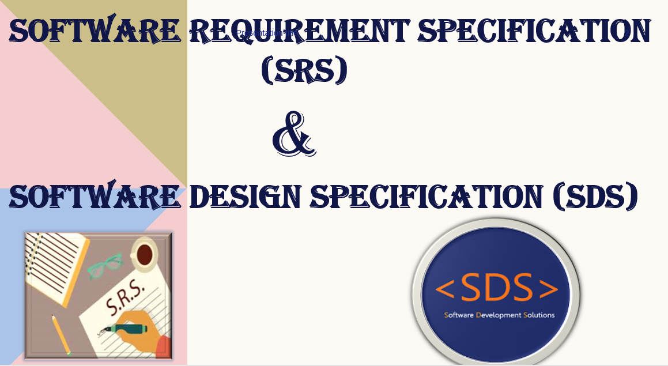

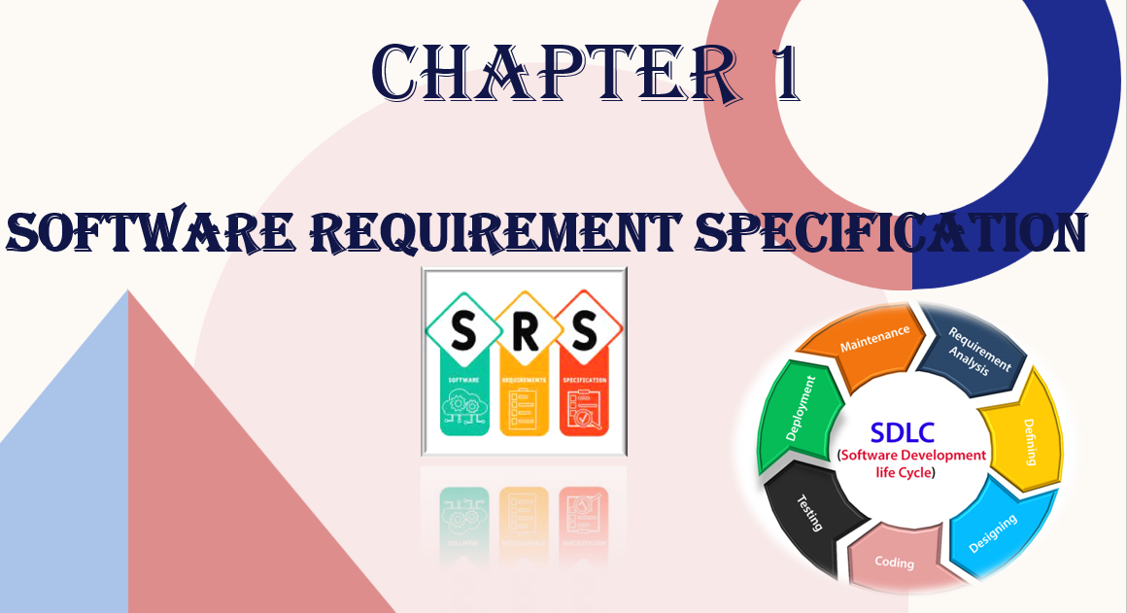

|  |
| --- |
| **Alive Dreams** |

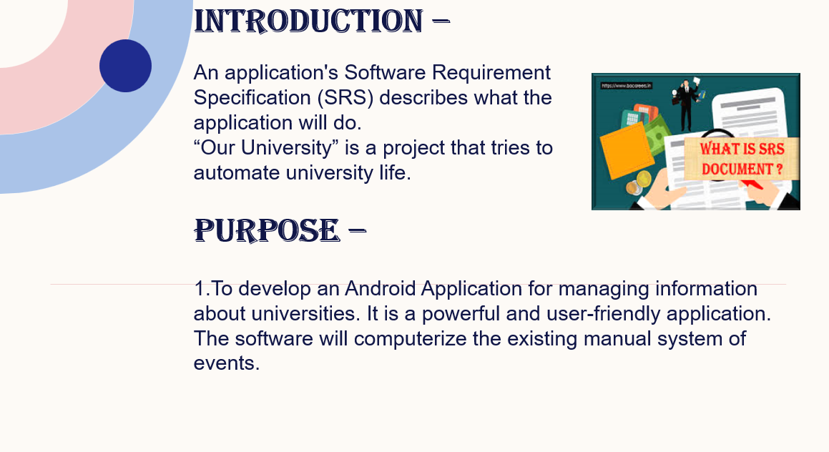

|  |
| --- |
| **Events** |

|  |
| --- |
| **Events** |

|  |
| --- |
| SCOPE - |

|  |
| --- |
| 1. Users can view the application and get the information |

|  |
| --- |
| regarding the events and can register for their favorite event. |

|  |
| --- |
| 2. System is able to handle extremely large volumes of data (i.e. |

|  |
| --- |
| large database support). |

|  |
| --- |
| 3. With the help of this app we can reduce our time . |



ACRONYMS

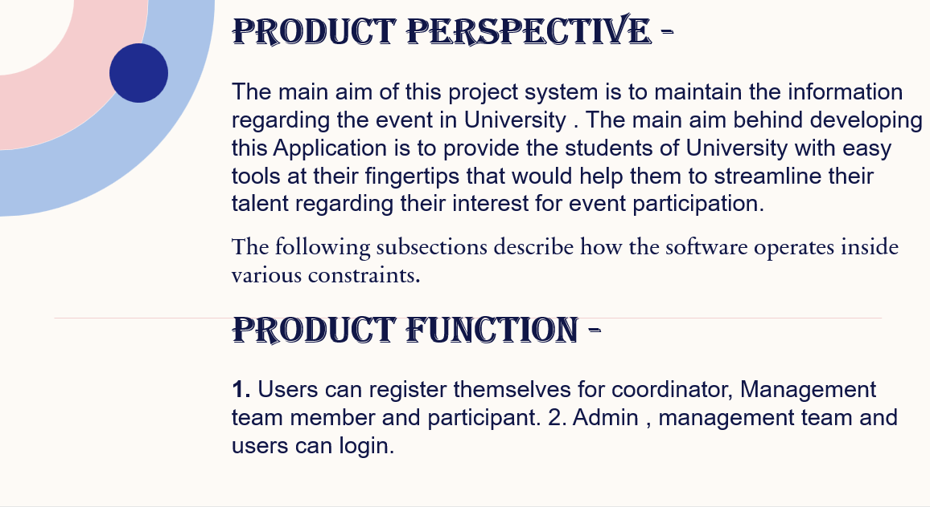

|  |
| --- |
| 3. Management can add new events. |

4. Users can select different technical and cultural events.

5. Participants can register for different workshops. 6. Students can post their feedback regarding events. 7. Result generation by mgmt .

8. Management Team members can manage different

|  |
| --- |
| Events. |

**Recommended 4 Gb Ram HDD: 400 MB hard disk space**   
**Processor: Intel Pentium dual core, 1.3GHz,**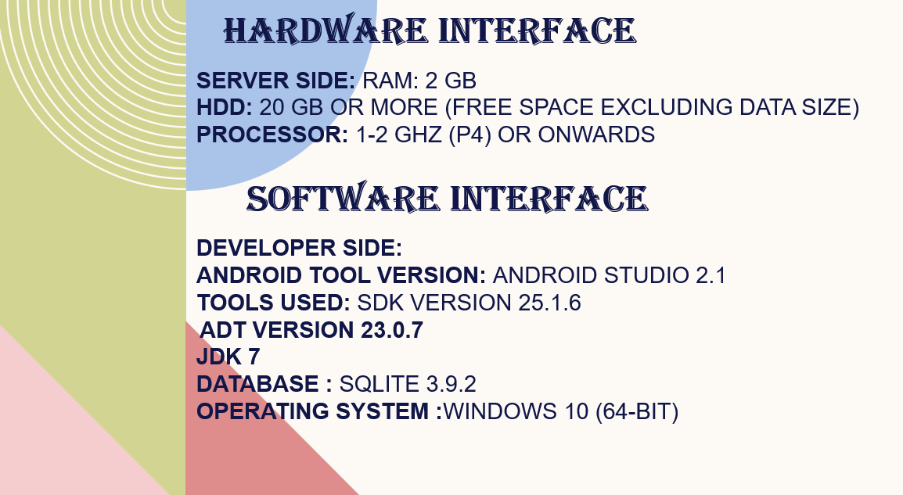

**Firebase**



**Client side**

Android version — 10.0 and higher.

RAM — Minimum RAM of 3 GB.

Processor modes — Qualcomm Snapdragon (version 630 and higher), Samsung Exynos, Hisilicon Kirim.

Location hardware — The device must have A-GPS and GPS + GLONASS + GALILEO

User Characteristics



management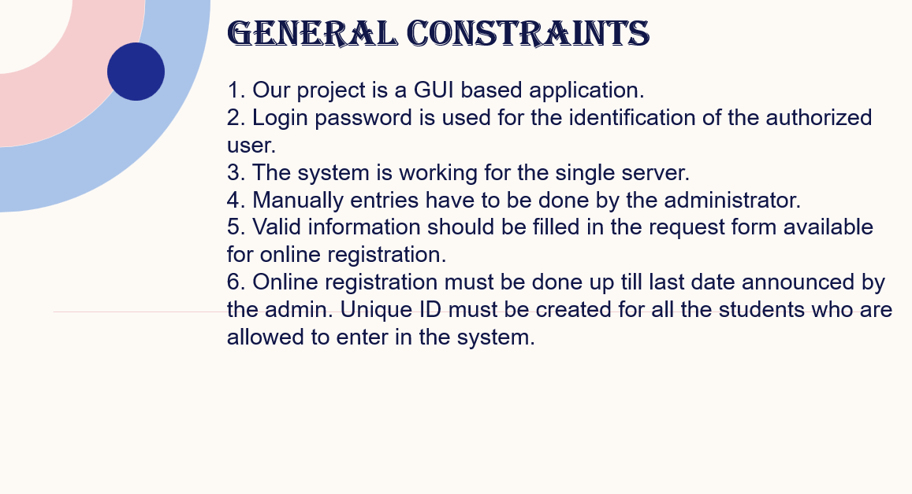

|  |
| --- |
| ASSUMPTIONS AND DEPENDENCIES |

|  |
| --- |
| 1. There is no change in user’s requirements. |

|  |
| --- |
| 2. Coordinator in this application will become |

|  |
| --- |
| the admin of the |

|  |
| --- |
| application after registration. |

|  |
| --- |
| 3. Users can login with their respective Smart Card ID and password. |

|  |
| --- |
| 4. System data must be correct. |

|  |
| --- |
| TECHNOLOGIES TO BE USED |

|  |
| --- |
| Front End: XML in Android Studio |

|  |
| --- |
| Back End: NoSql and Java 8 |

|  |
| --- |
| Other Tools and technologies: Android Studio 4.4 |

|  |
| --- |
| Web Server: FIREBASE |

|  |
| --- |
| SPECIFIC REQUIRMENTS |

|  |
| --- |
| Module 1 - Login |

|  |
| --- |
| Module 2 - Registration |

|  |
| --- |
| Module - 3 Event |

|  |
| --- |
| Module 4 - Administration team |

|  |
| --- |
| Module 5 - Results |

|  |  |  |  |
| --- | --- | --- | --- |
| |  | | --- | | USE CASE - 1 |  |  | | --- | | LOGIN | |  |

|  |  |
| --- | --- |
| USE CASE - 2  REGISTRATION | High |

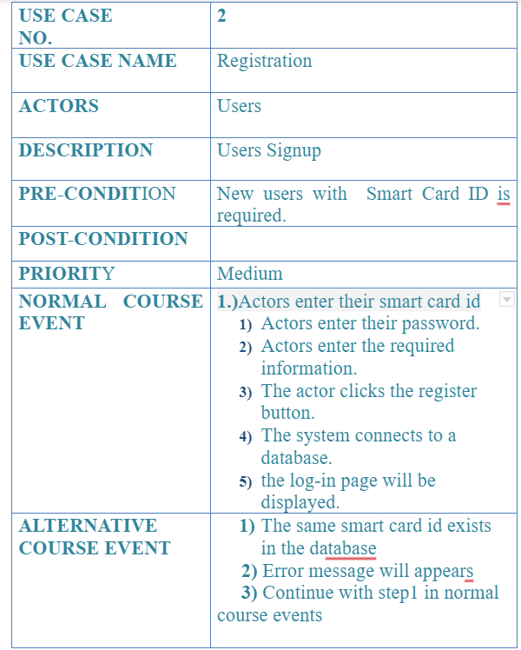

|  |
| --- |
| TOOL |

|  |  |  |
| --- | --- | --- |
| USE CASE -3 | high | **High** |
| MANAGEMENT |

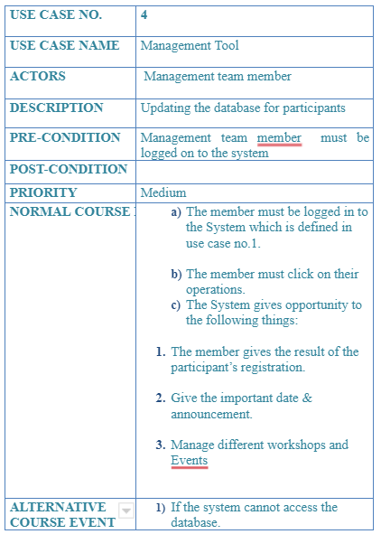

|  |
| --- |
| TEAM TOOL |

|  |
| --- |
| USE CASE -3 |

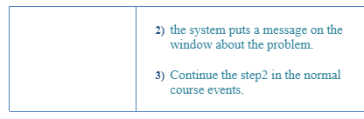

|  |
| --- |
| MANAGEMENT |

|  |
| --- |
| TEAM TOOL |

|  |  |
| --- | --- |
| USE CASE - 4 PARTICIPANTS TOOL |  |

|  |
| --- |
| USE CASE |

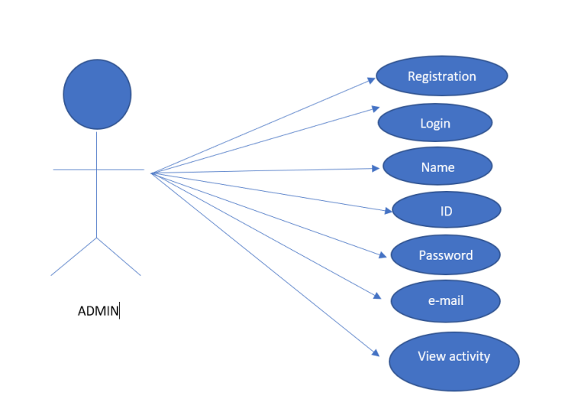

|  |
| --- |
| DIAGRAM FOR |

|  |
| --- |
| ADMIN |

|  |  |  |  |
| --- | --- | --- | --- |
| |  | | --- | | USE CASE |   DIAGRAM FOR   |  | | --- | | MANAGEMENT | |  |

|  |  |  |  |
| --- | --- | --- | --- |
| |  | | --- | | USE CASE |   DIAGRAM FOR   |  | | --- | | PARTICIPANTS | |  |

|  |  |  |  |
| --- | --- | --- | --- |
| |  | | --- | | USE CASE |   DIAGRAM FOR   |  | | --- | | VISITOR | |  |





**Software**   
**Document**   
**Specification**

Software Document Specification tells us

HOW our software is going to be built

|  |
| --- |
| ACTIVITY DIAGRAM |

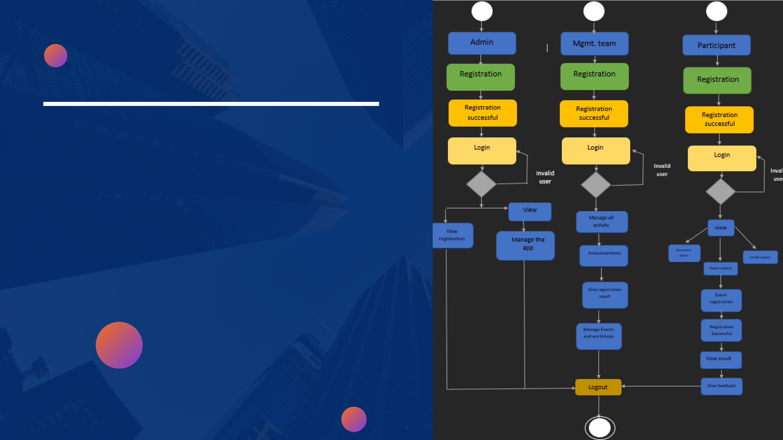

|  |
| --- |
| Activity diagrams are graphical |

representation of workflows of   
stepwise activities and actions with support for choice, iteration

|  |
| --- |
| and concurrency. |

|  |  |  |  |
| --- | --- | --- | --- |
| |  | | --- | | **SEQUENCE DIAGRAM** |  |  | | --- | | **FOR ADMIN** | |  |

|  |  |  |  |
| --- | --- | --- | --- |
| |  | | --- | | **SEQUENCE DIAGRAM** |  |  | | --- | | **FOR MANAGEMENT** | |  |

|  |  |  |  |
| --- | --- | --- | --- |
| |  | | --- | | **SEQUENCE DIAGRAM FOR** |  |  | | --- | | **PARTICIPANTS** | |  |

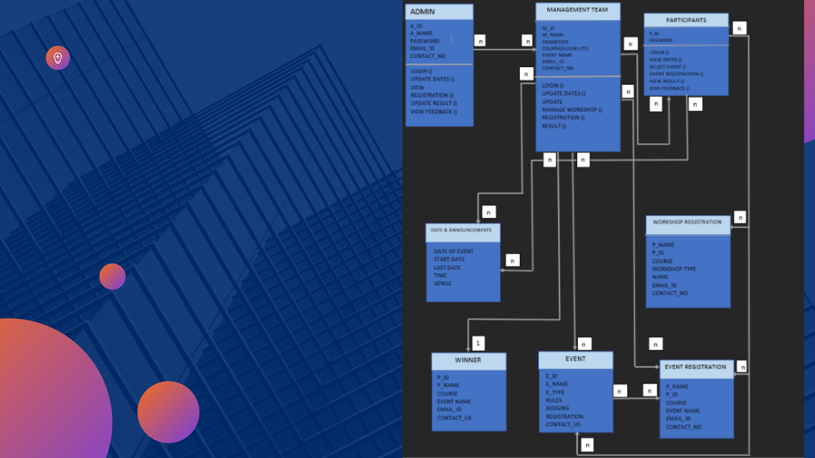

A class diagram in UML is a type of static   
structure diagram that   
describes the structure of a system by   
showing the system’s   
classes, their attributes, operations (or   
methods), and the   
relationships among objects.

Classes are:   
1. **Admin**   
2. **ManagementTeam**   
3. **Participants**   
4. **Dates and Announcements**   
5. **Event**   
6. **Event Registration**   
7. **Workshop registration**

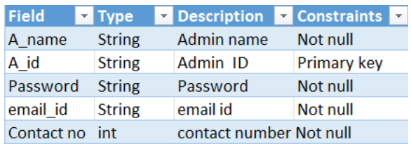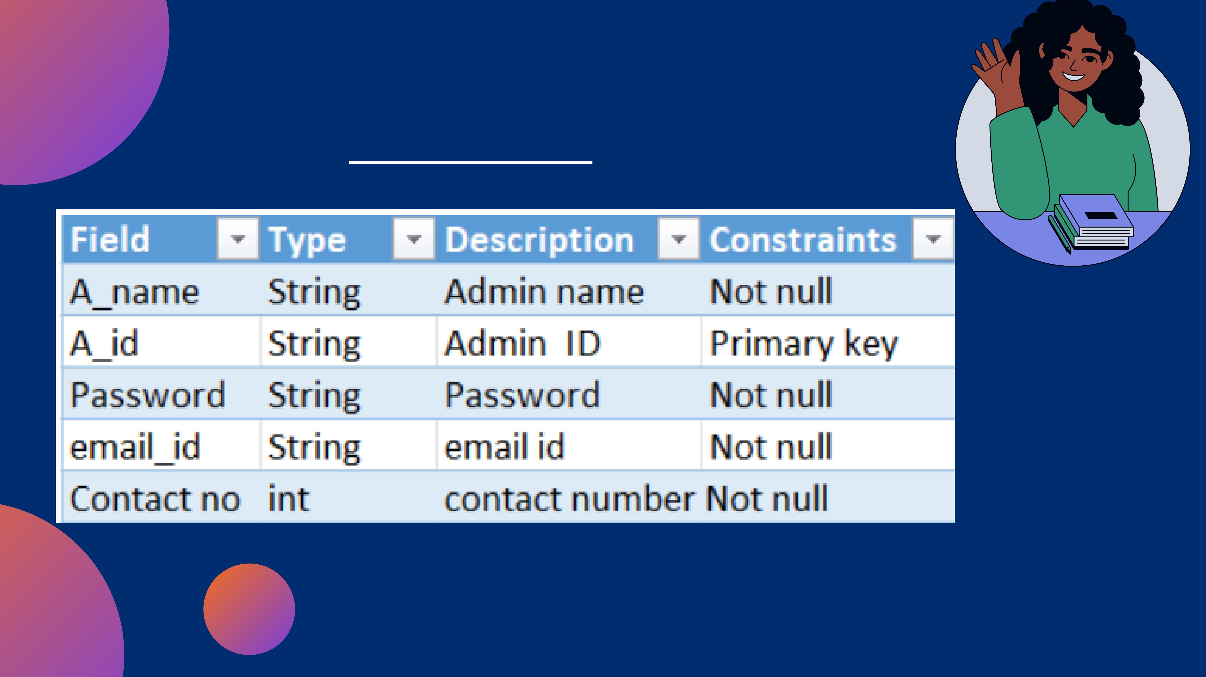

**COMPONENT INTERFACE**   
**DESCRIPTION**

**ADMIN TABLE**

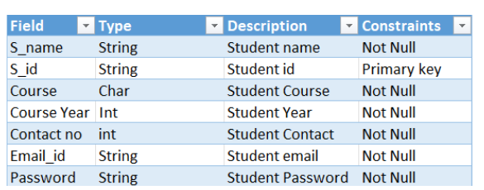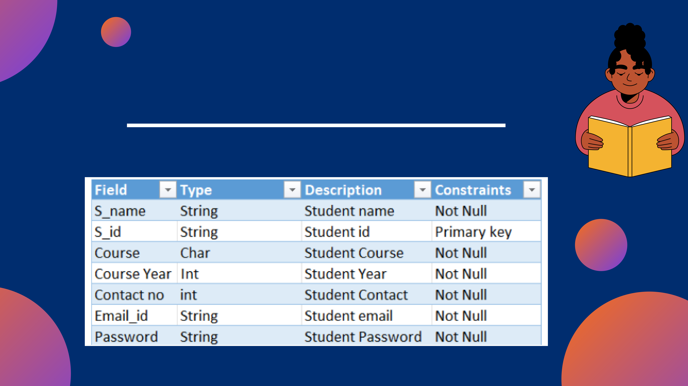

STUDENT REGISTRATION

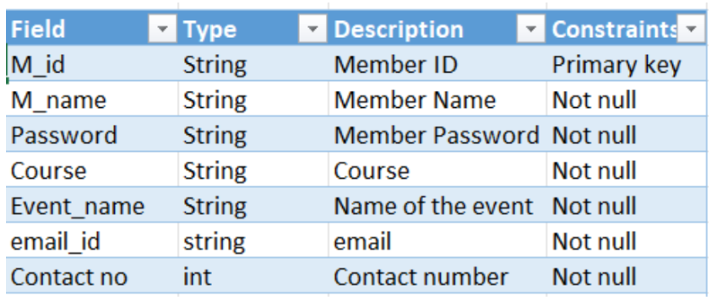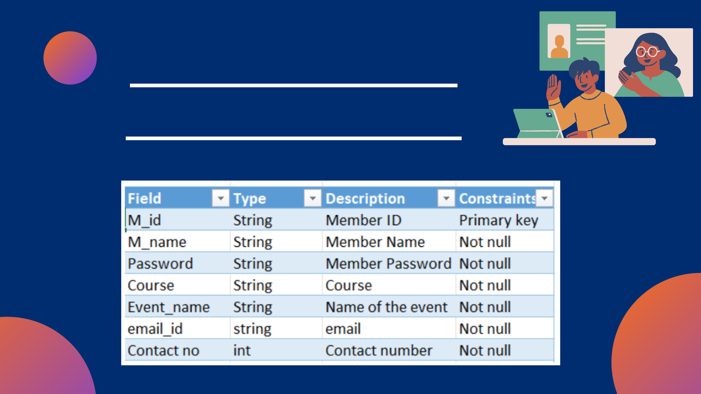

MANAGEMENT TEAM REGISTRATION TABLE

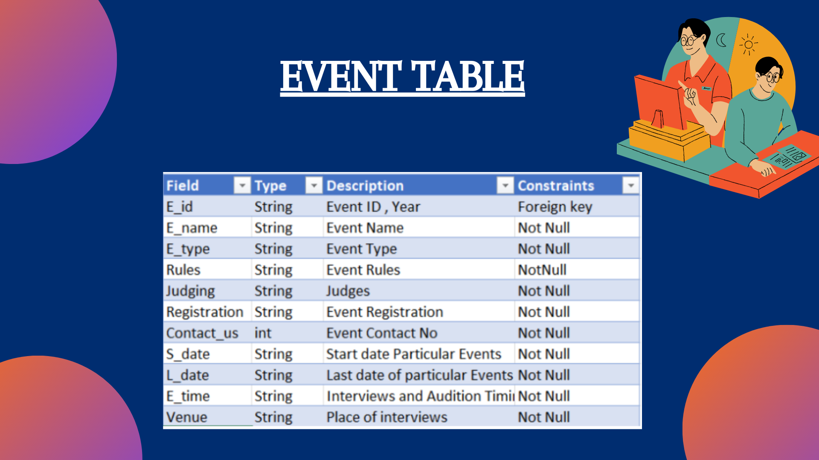

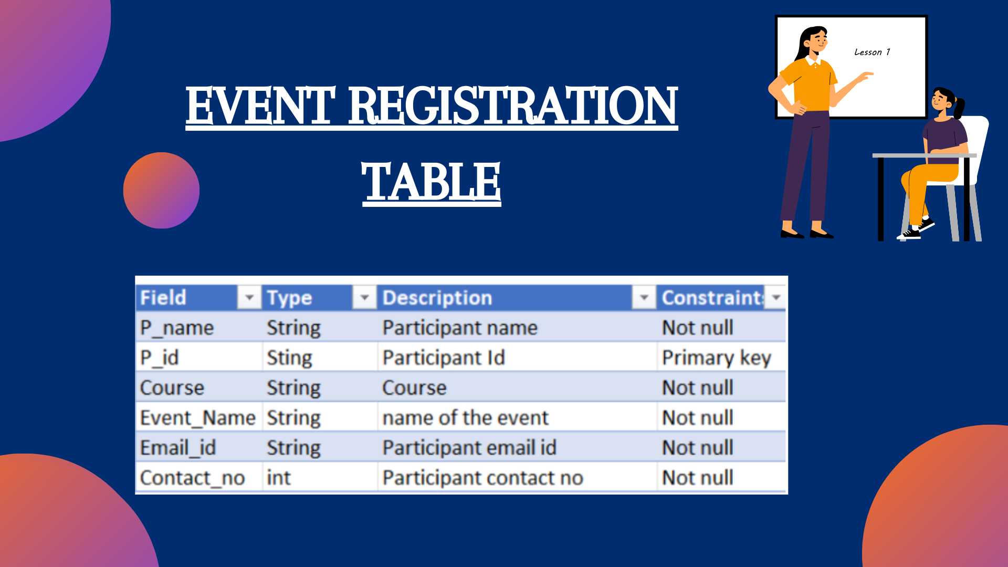

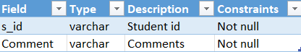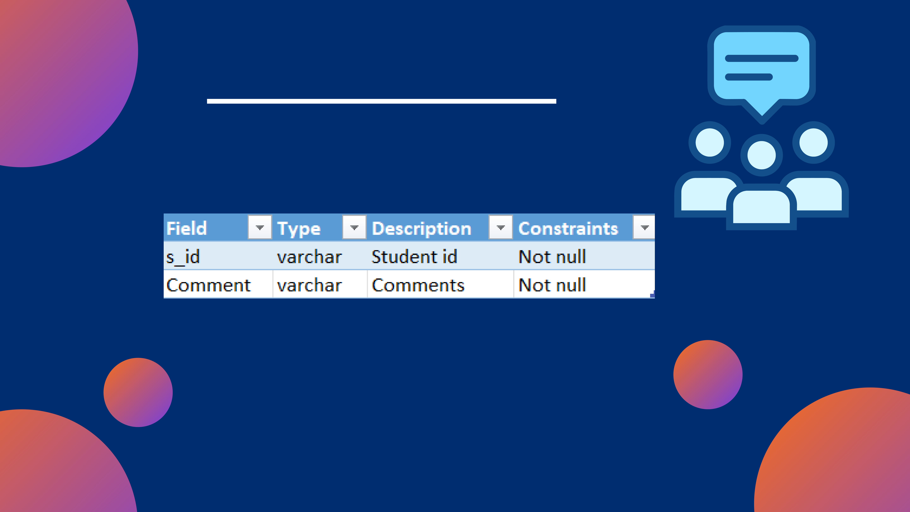

FEEDBACK TABLE

|  |  |
| --- | --- |
| |  | | --- | |  | |

|  |  |
| --- | --- |
| |  | | --- | |  | |

|  |  |
| --- | --- |
| |  | | --- | |  | |

|  |  |
| --- | --- |
| |  | | --- | |  | |

|  |  |
| --- | --- |
| |  | | --- | |  | |

|  |  |
| --- | --- |
| |  | | --- | |  | |

|  |  |
| --- | --- |
| |  | | --- | |  | |

|  |  |
| --- | --- |
| |  | | --- | |  | |

|  |  |
| --- | --- |
| |  | | --- | |  | |